Contents

Bringing up Ubuntu 1

Install Java 5

Error while installation : Failed to Fetch 6

Then re-ran java installation it worked 7

Set JAVA Path 8

Java installed 9

Install Jenkins 9

# Bringing up Ubuntu

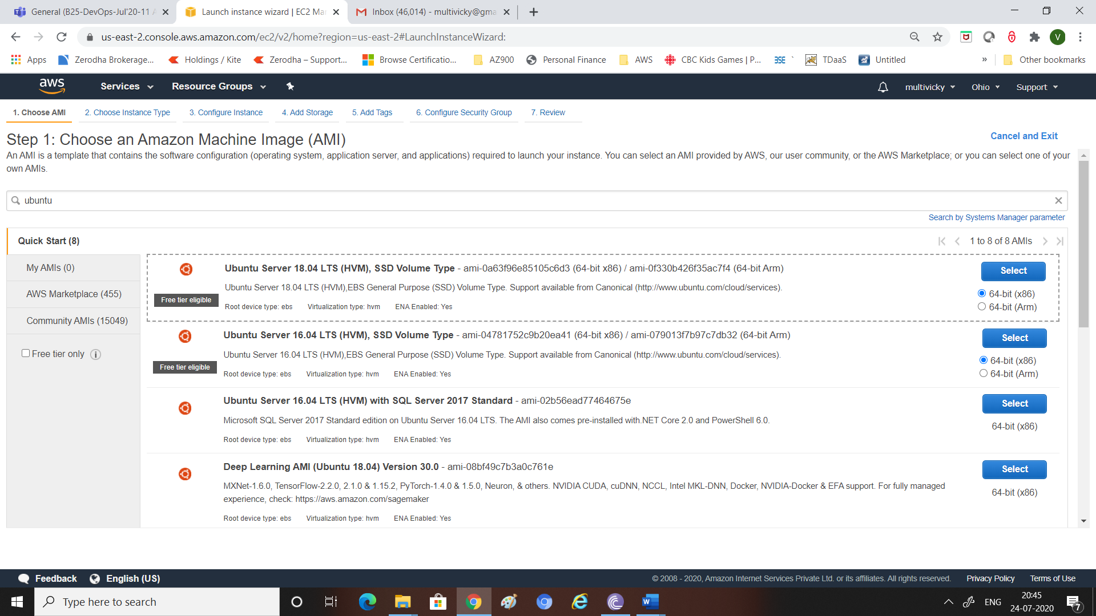

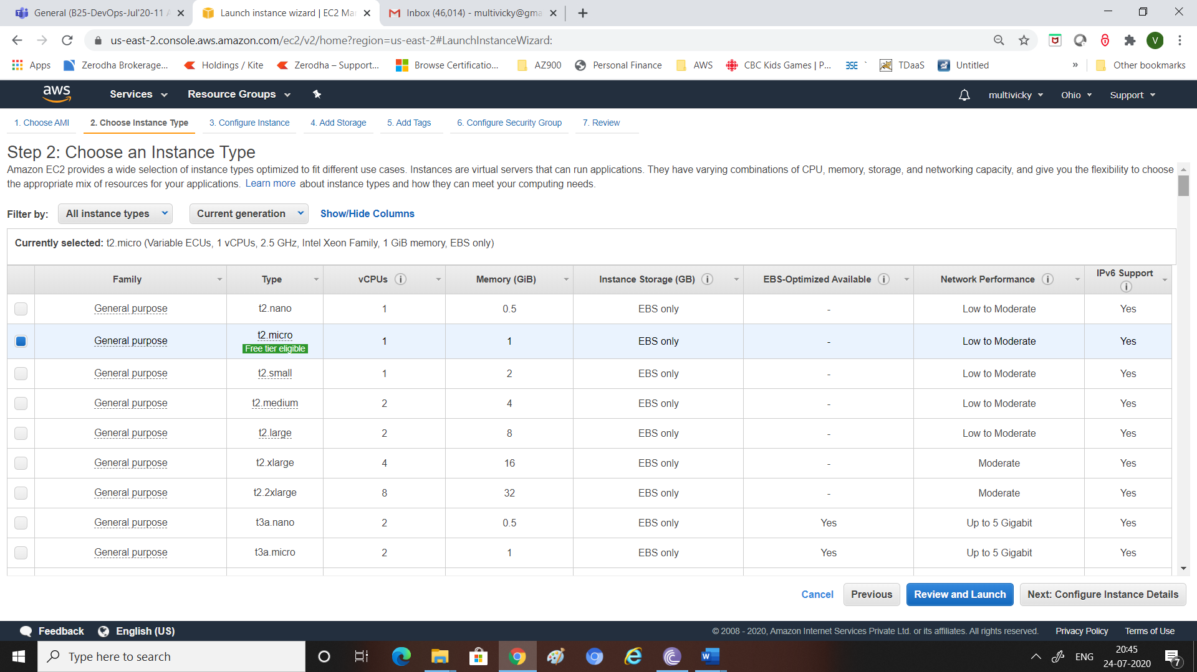

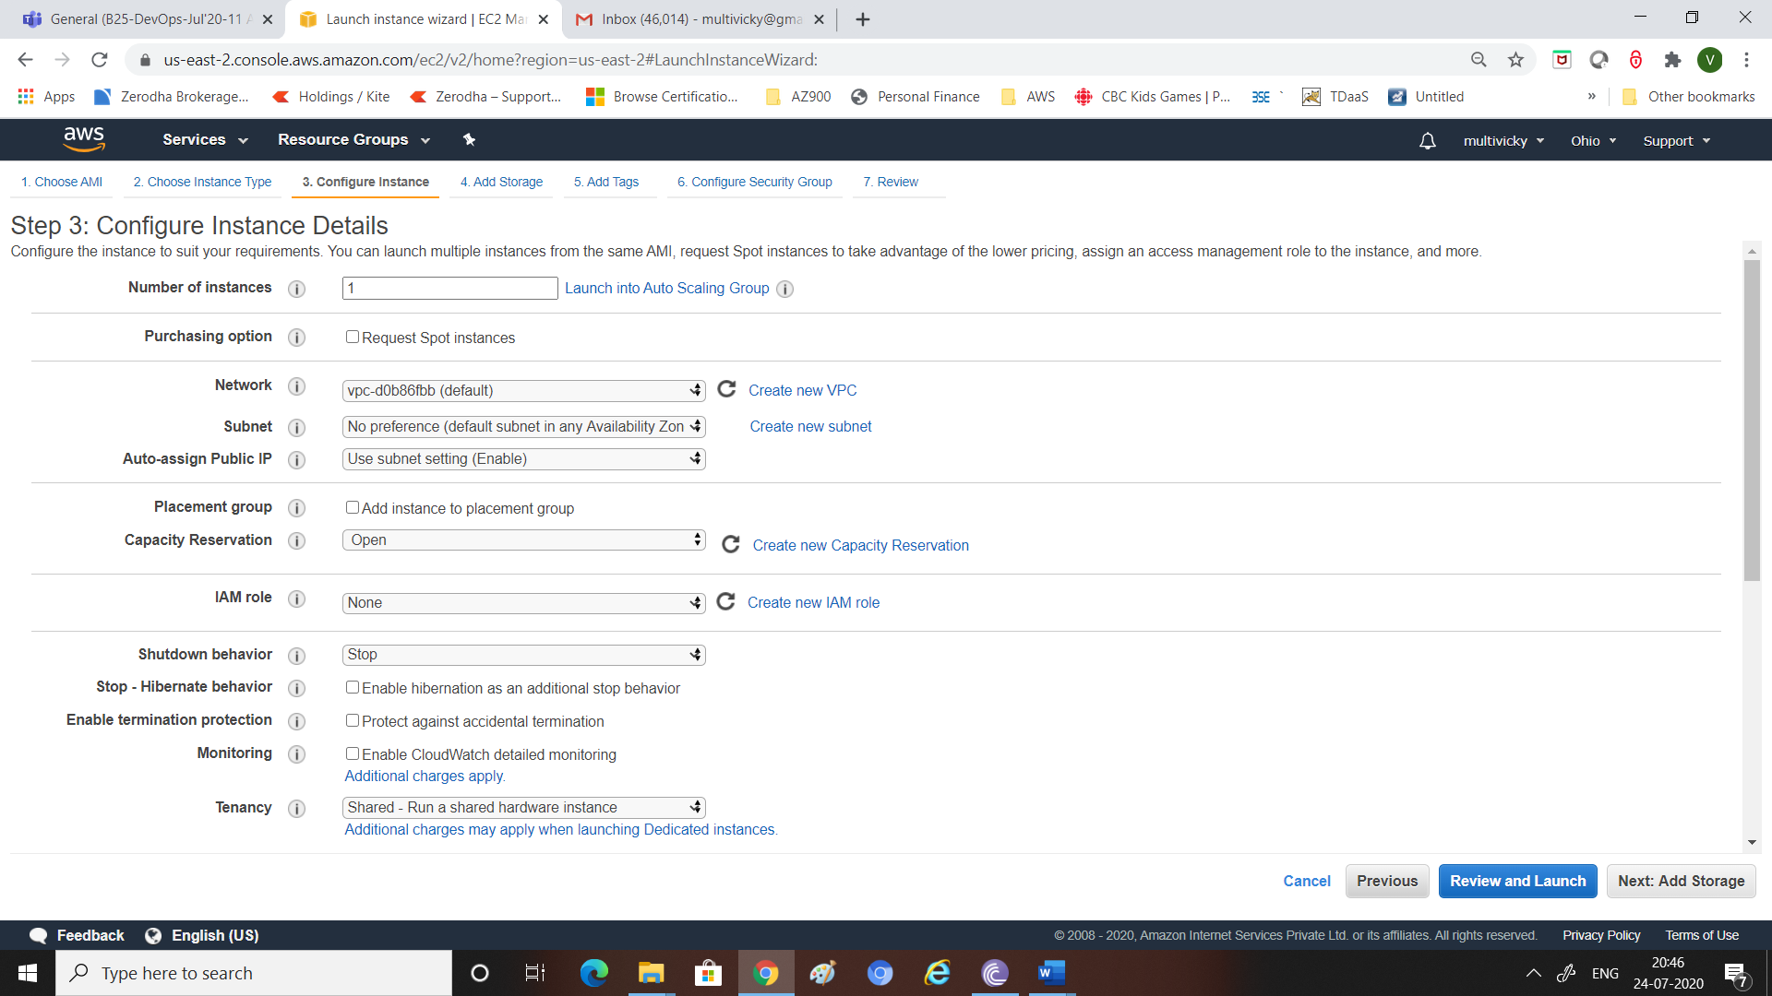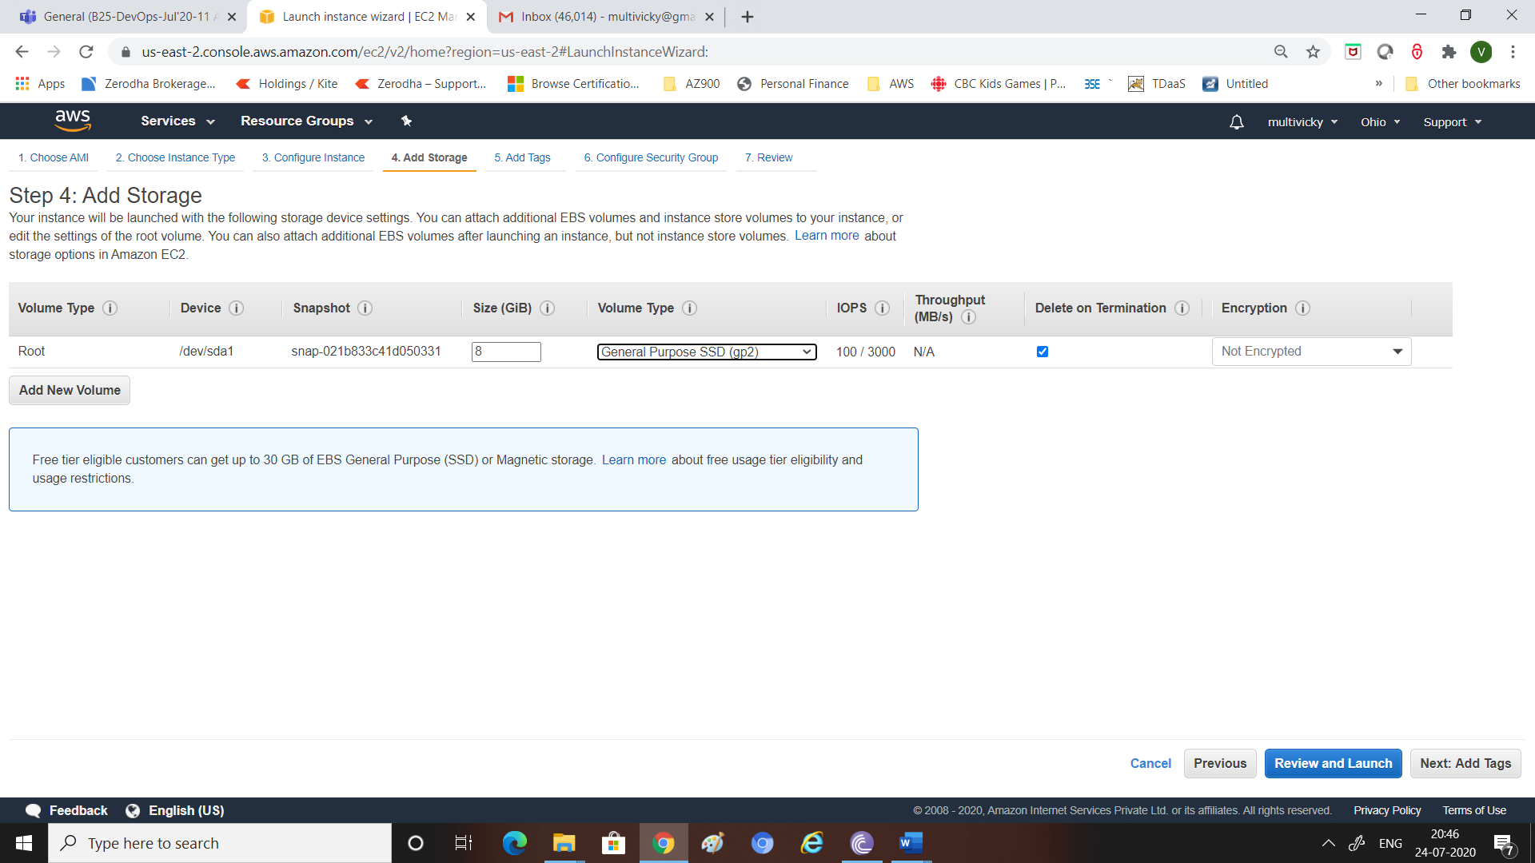

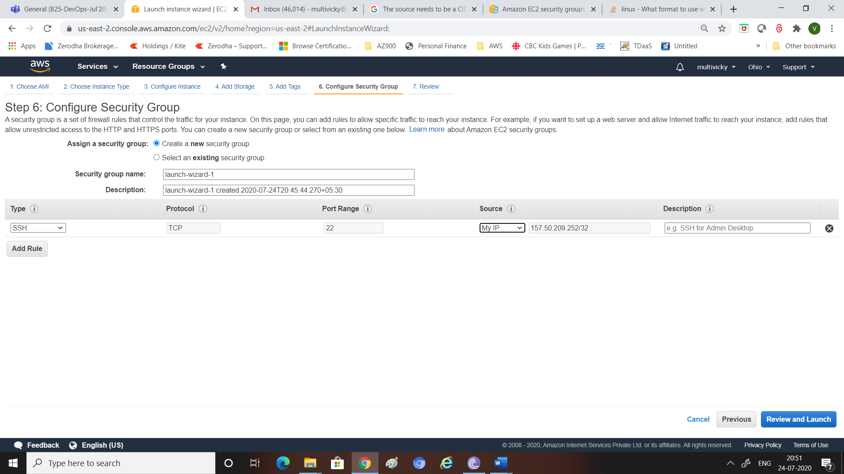

Changed ip to 0.0.0.0/0 to make it work during connectivity

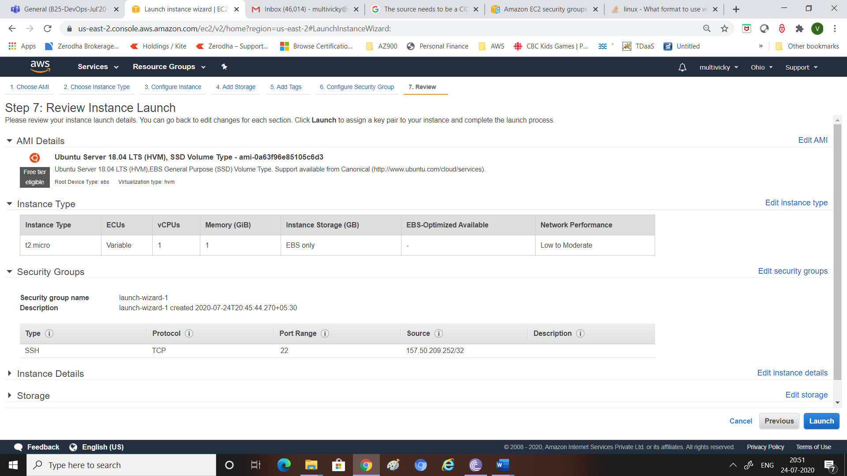

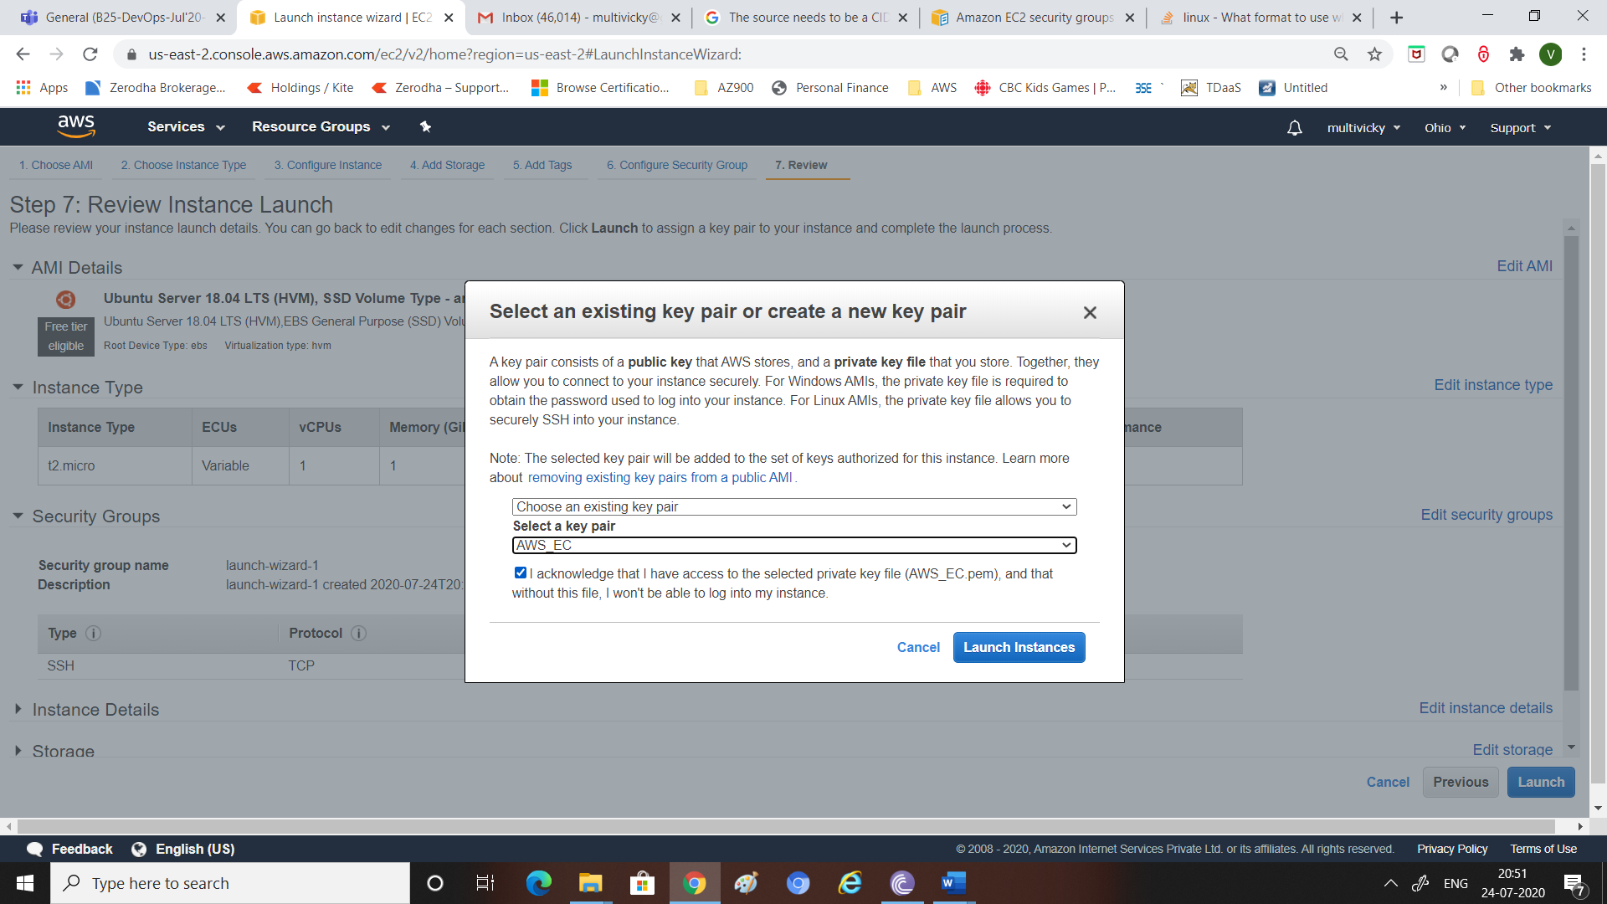

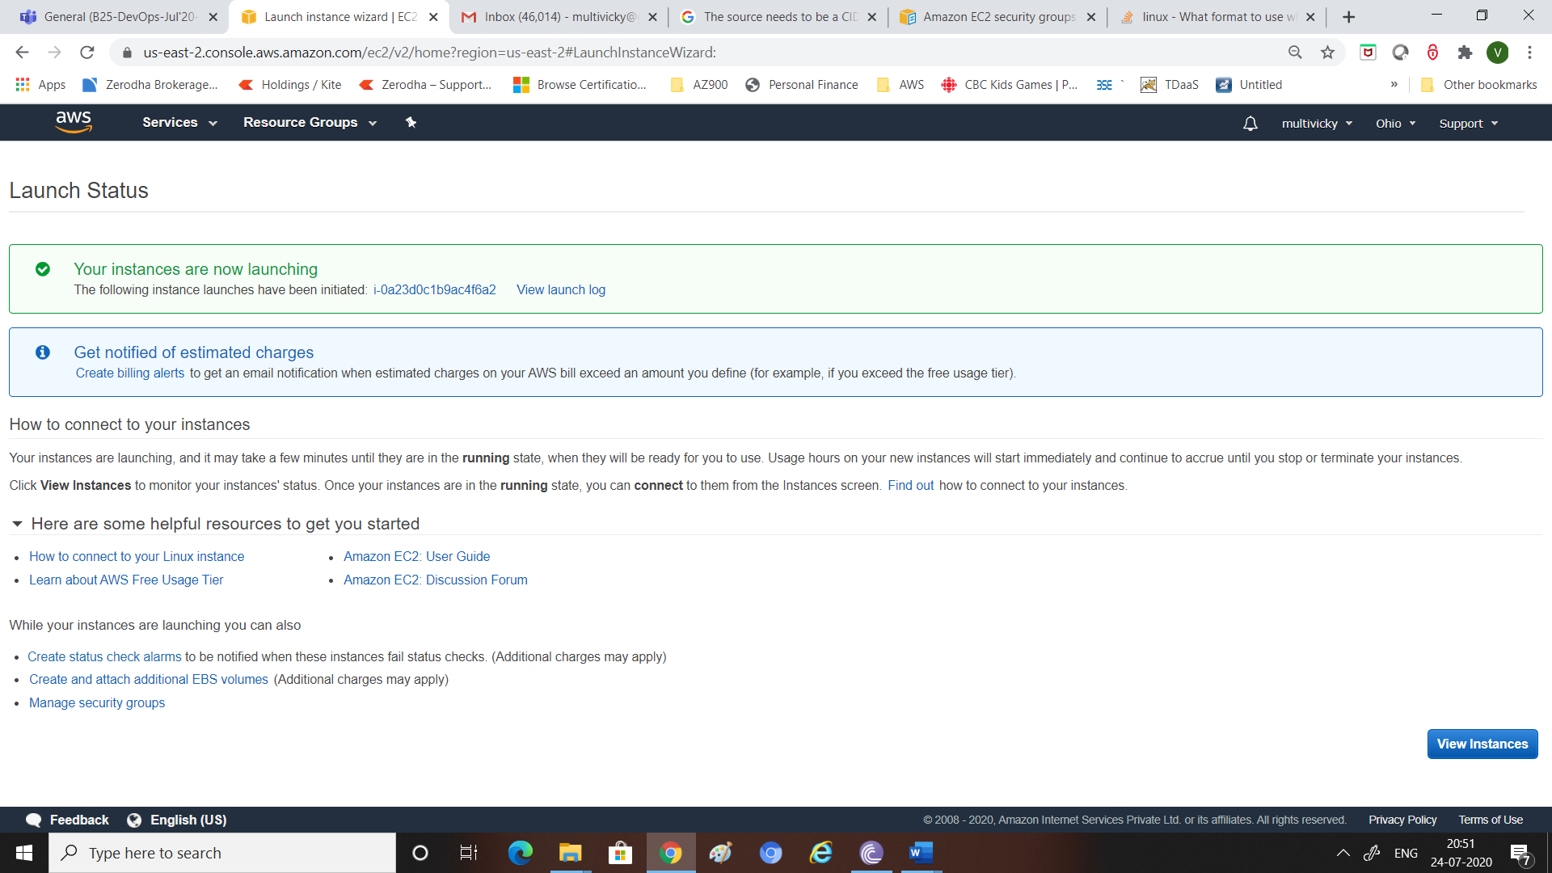

Connect via Moba using Public IP address and keypair

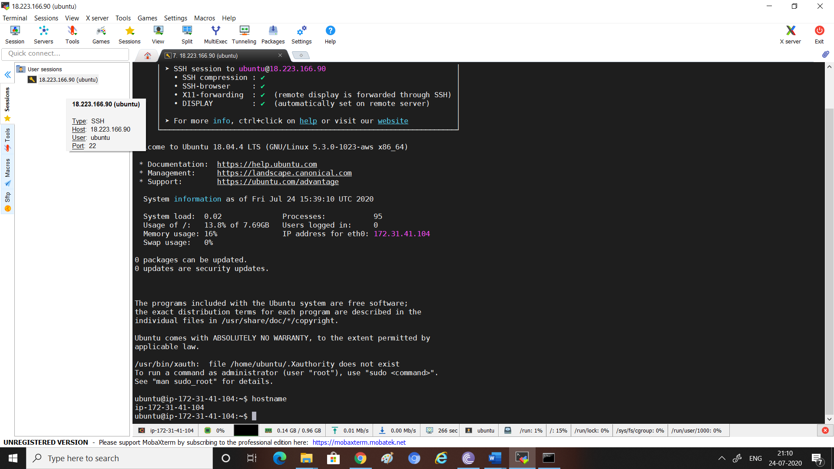

Check java

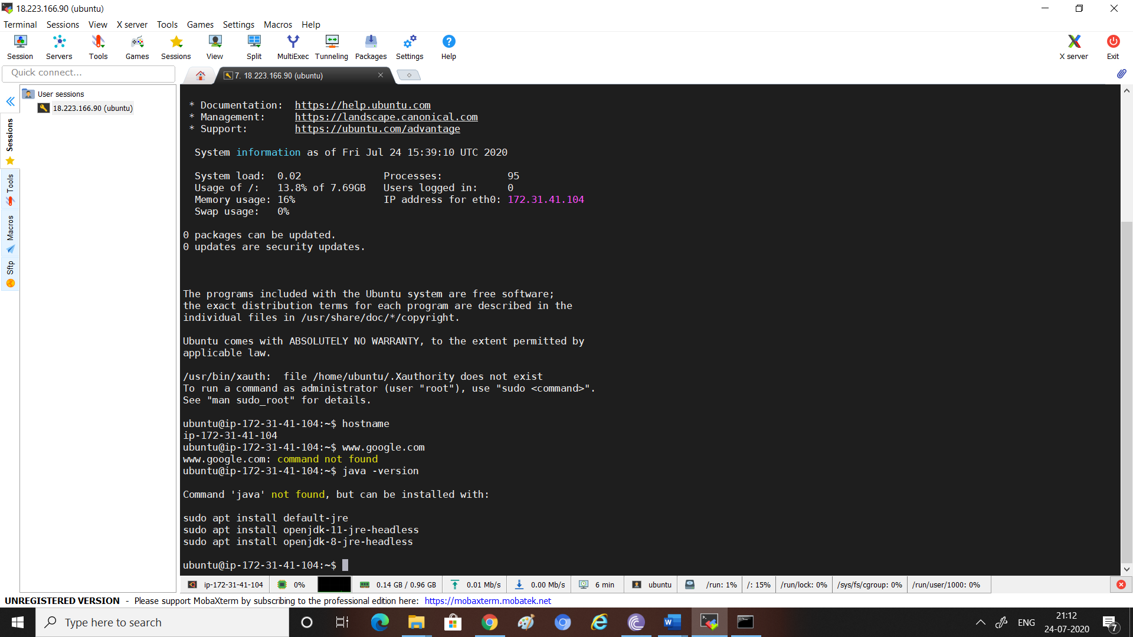

# Install Java

sudo apt install openjdk-11-jdk

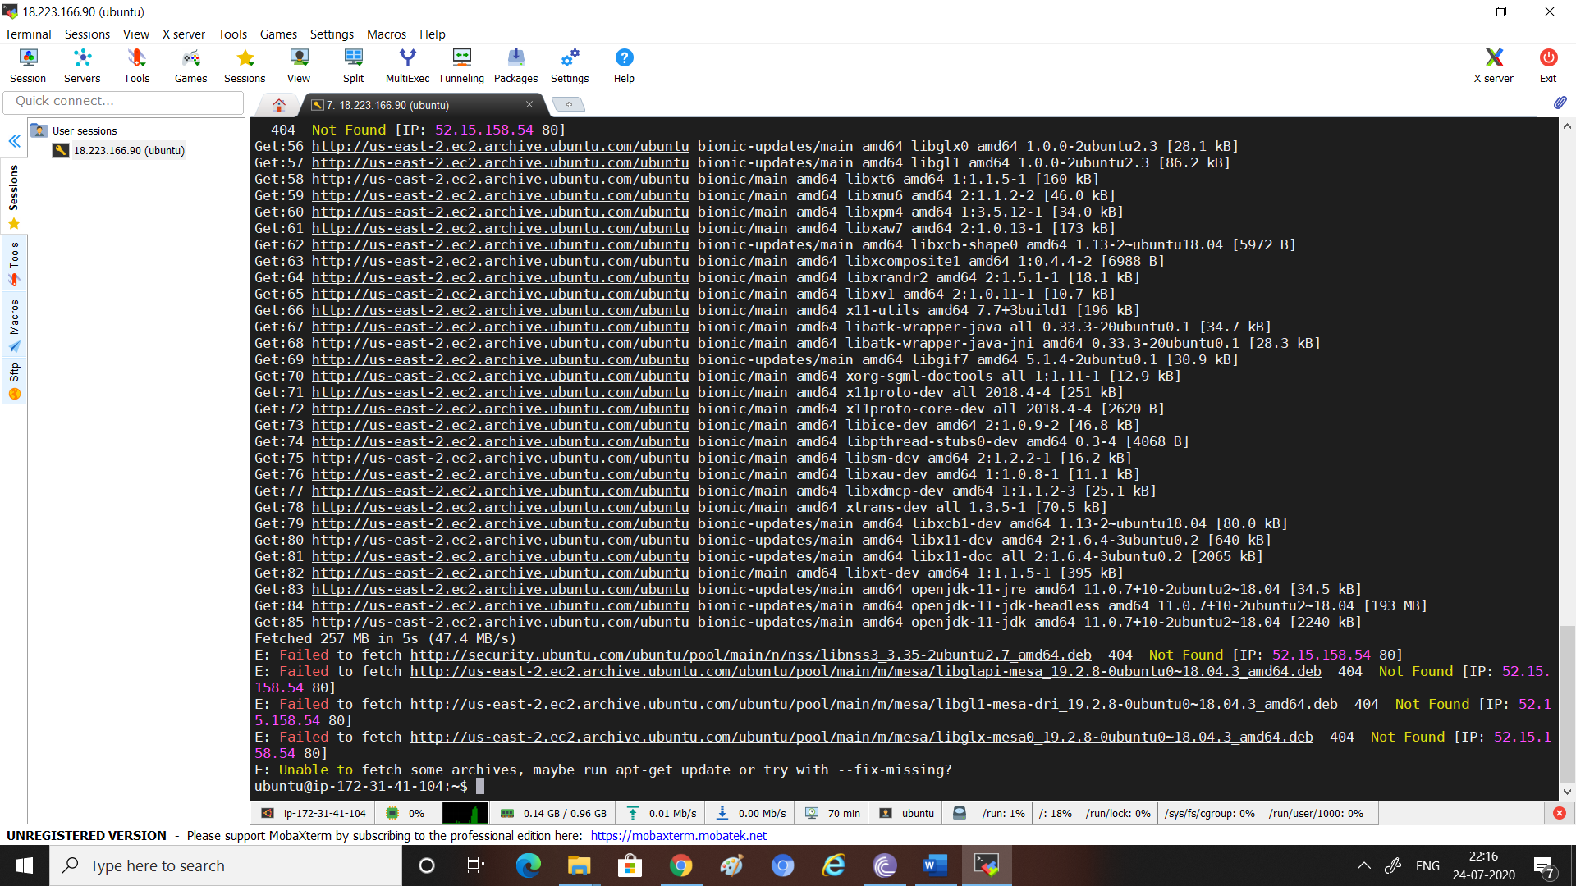

# Error while installation : Failed to Fetch

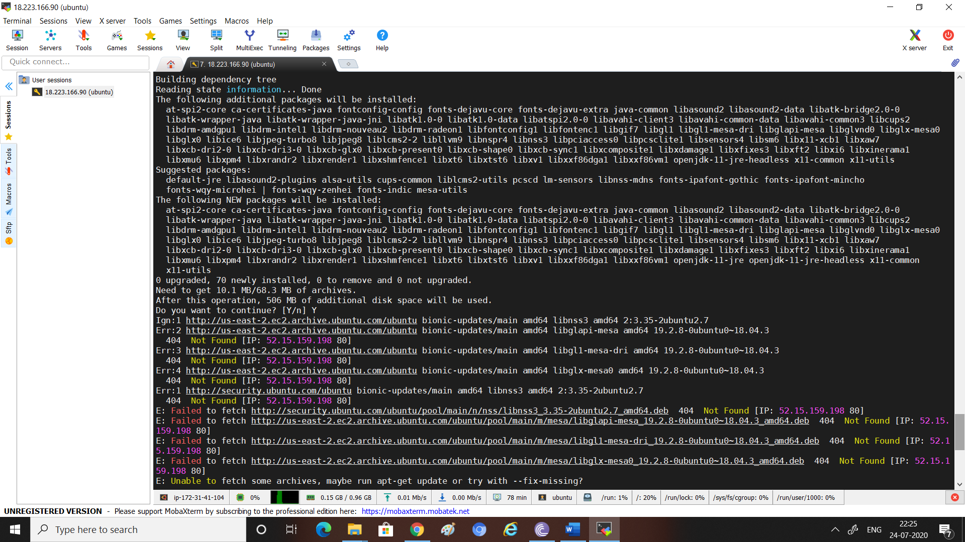

sudo apt-get update

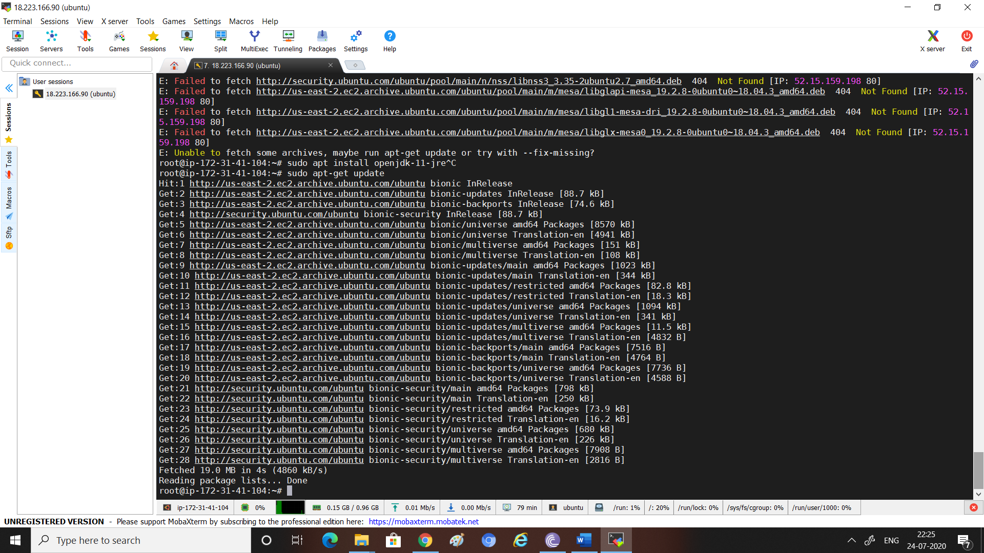

# Then re-ran java installation it worked

sudo apt install openjdk-11-jdk

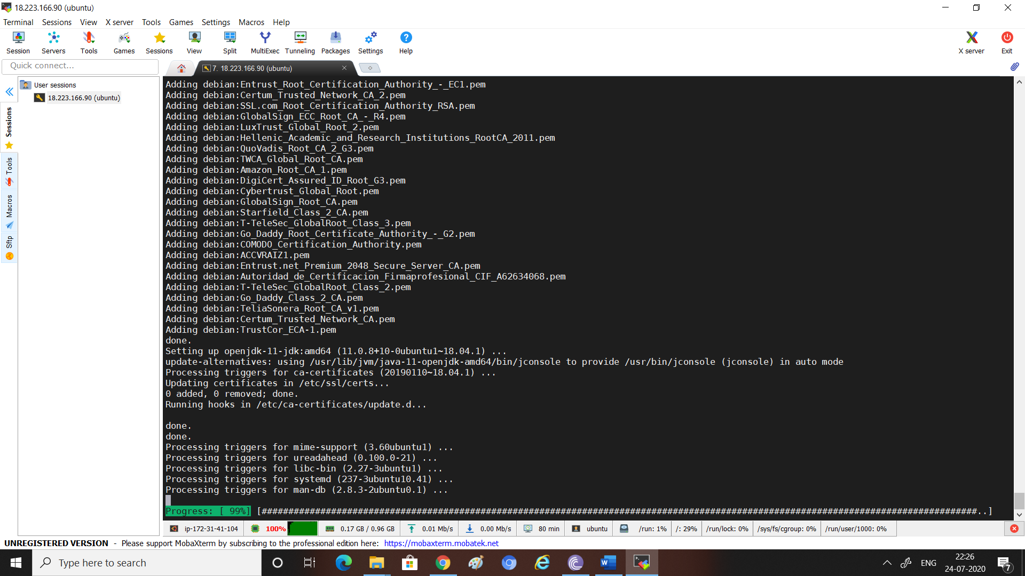

# Set JAVA Path

set environment variables as follows

Edit the system Path file /etc/profile

sudo gedit /etc/profile

Add following lines in end

JAVA_HOME=/usr/lib/jvm/jdk1.7.0

PATH=$PATH:$HOME/bin:$JAVA_HOME/bin

export JAVA_HOME

export JRE_HOME

export PATH

Then Log out and Log in ubuntu for setting up the paths...

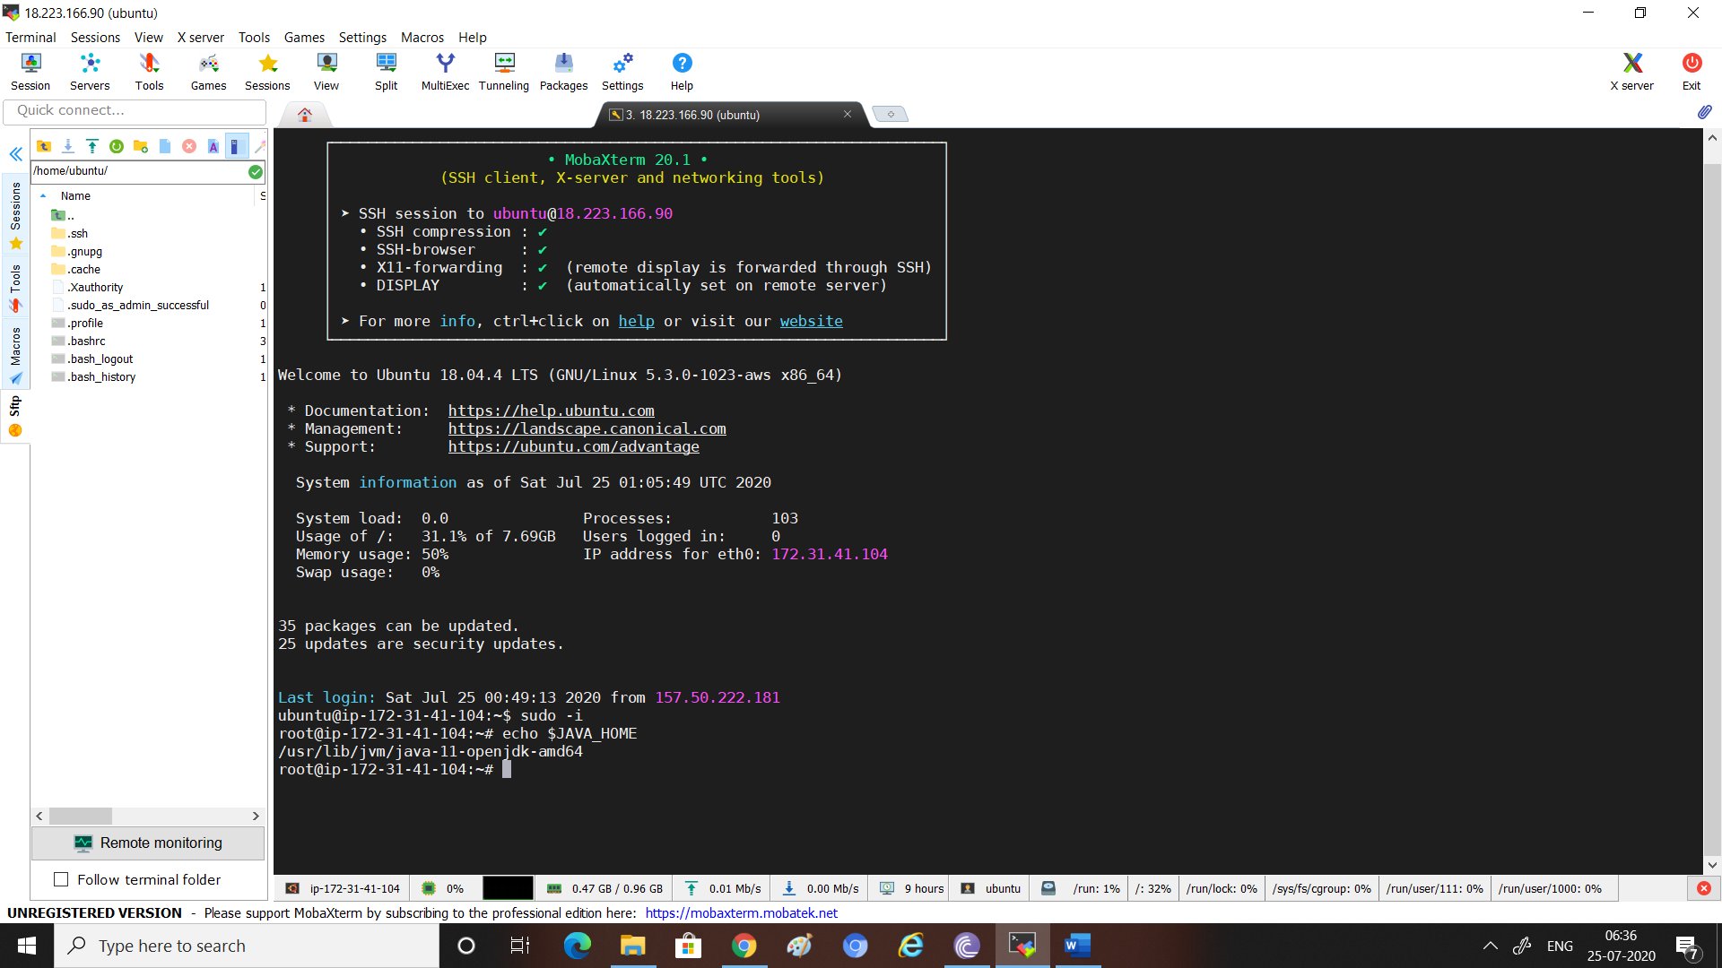

# Java installed

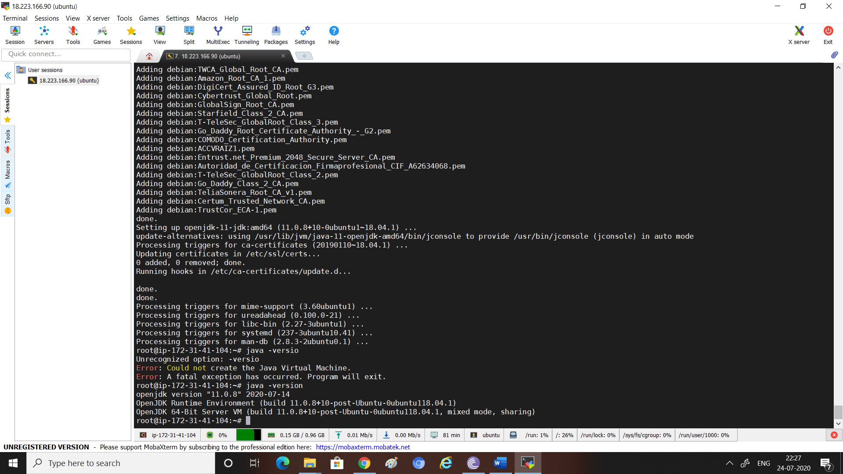

# Install Jenkins

<https://www.digitalocean.com/community/tutorials/how-to-install-jenkins-on-ubuntu-18-04>

wget -q -O - http://pkg.jenkins-ci.org/debian/jenkins-ci.org.key | sudo apt-key add

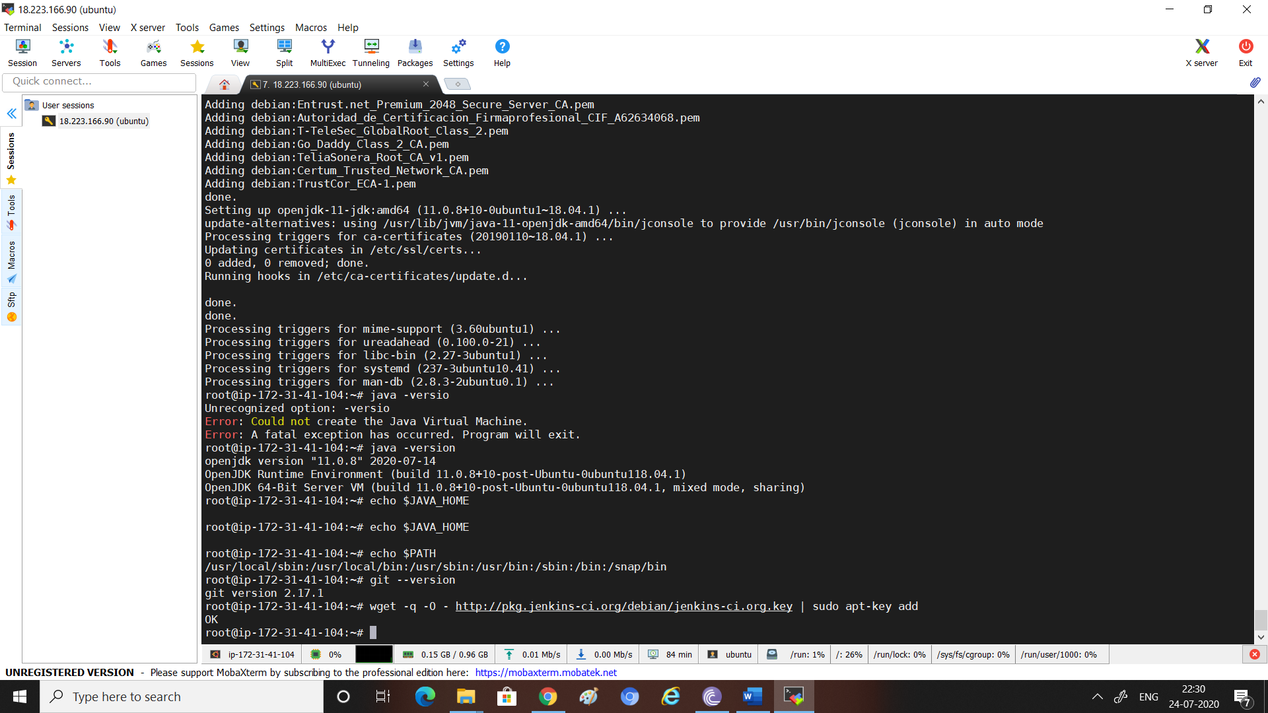

* sudo sh -c 'echo deb http://pkg.jenkins-ci.org/debian-stable binary/ > /etc/apt/sources.list.d/jenkins.list'

sudo apt update

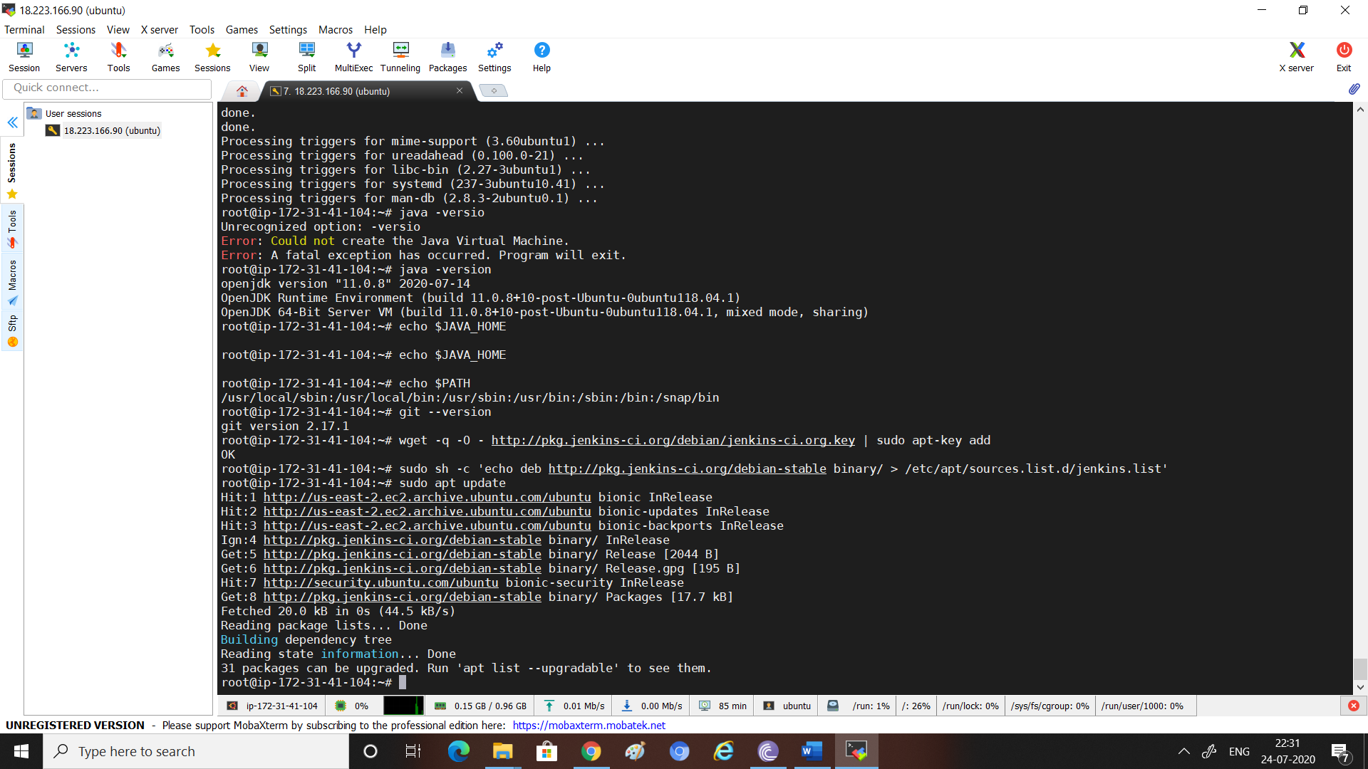

sudo apt install Jenkins

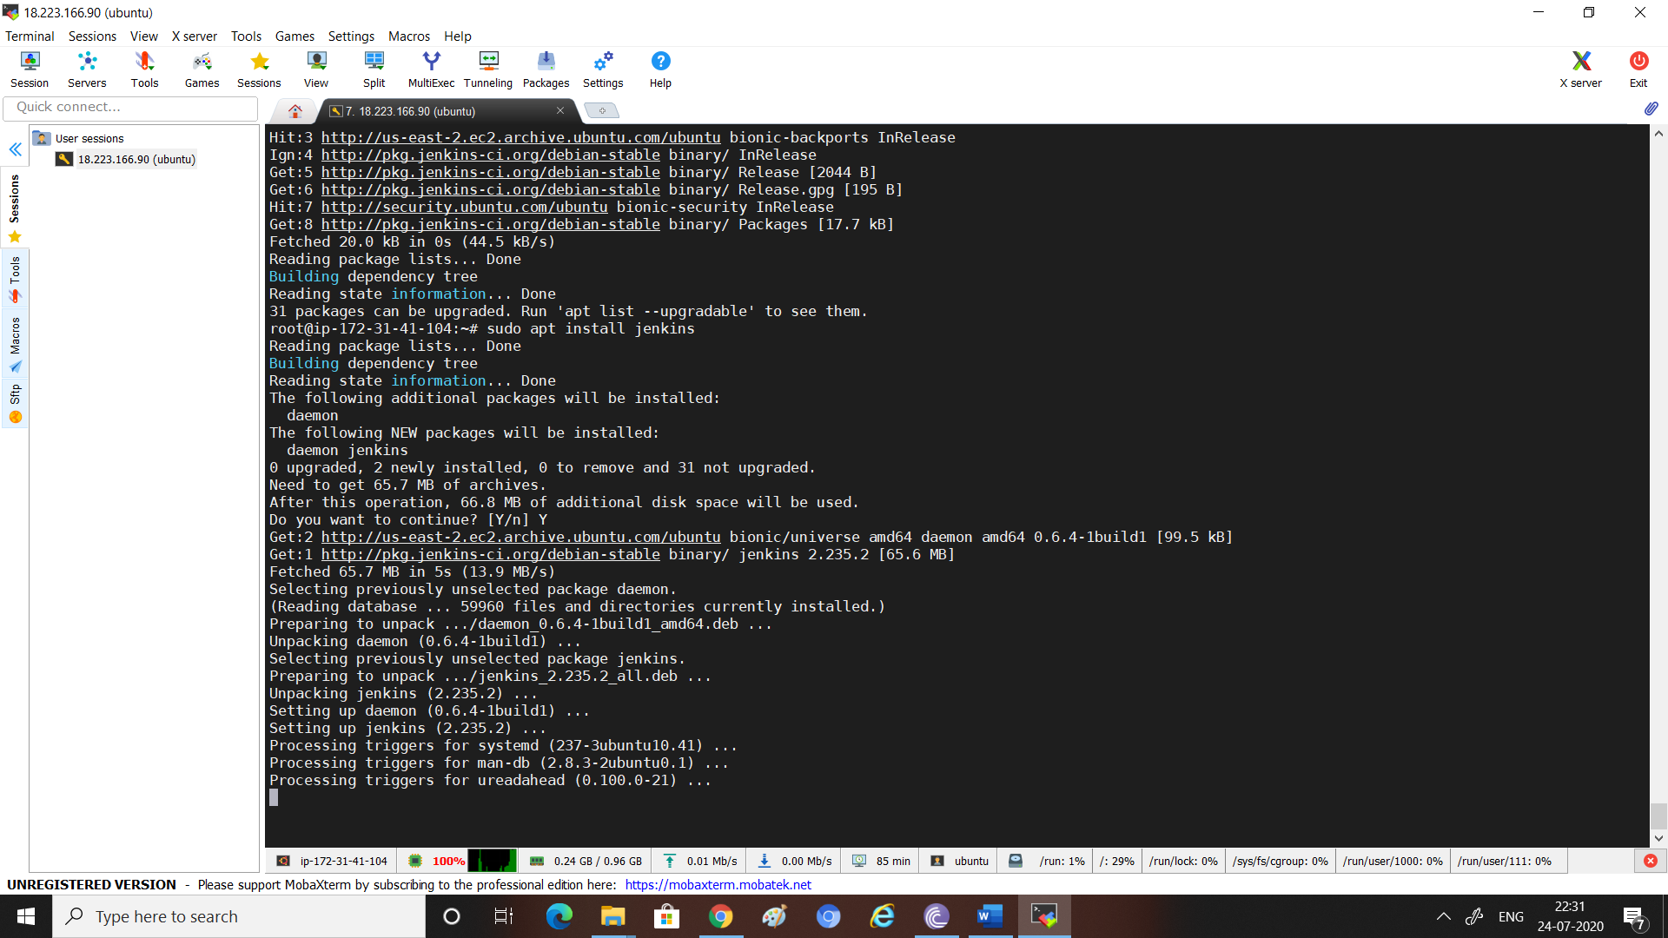

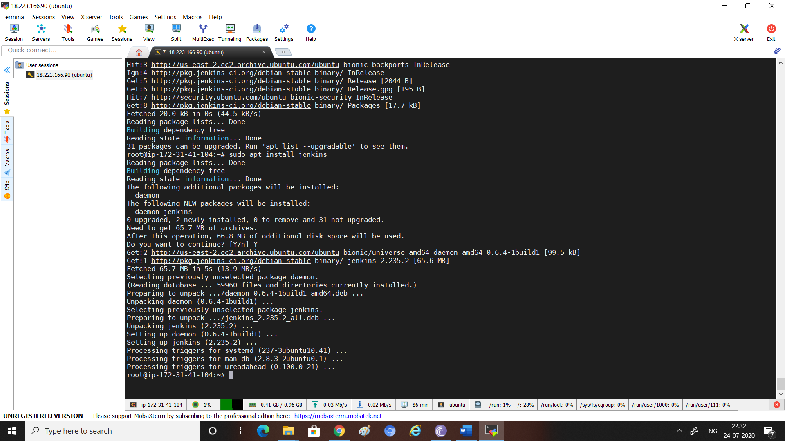

sudo ufw allow 8080

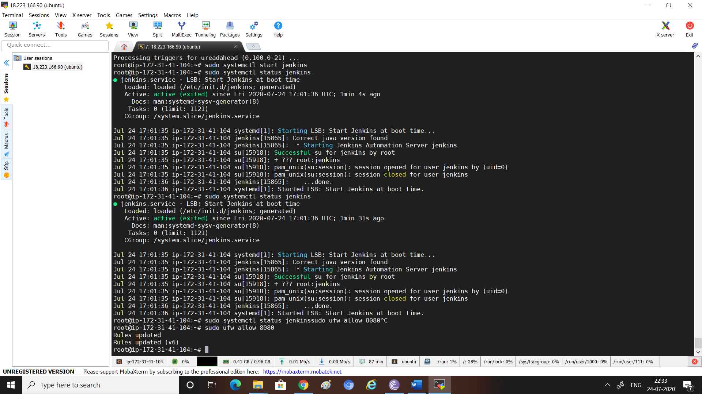

# Unable to launch Jenkins, until inbound rules edited in AWS instance

Steps:

1. Go to AWS console
2. Click Security Group and select the security group that you have assigned to your EC2 instance.
3. Click Edit Inbound Rules
4. Add a Custom TCP Rule and add 8080 in the Port Range.
5. You will now see Jenkins rise from the grave :) i.e. first time installation screen.

P.S.: My Friend, if you have reached till Step 5, you know what to do next ;)

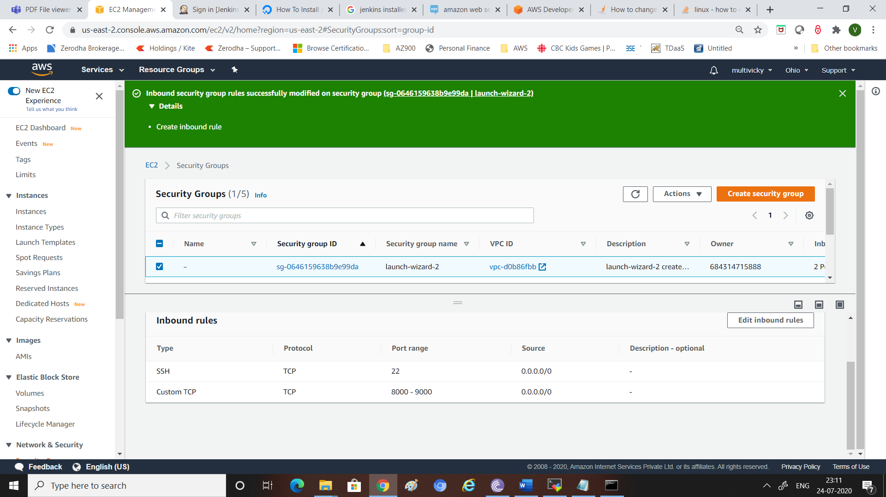

Updated inbound rules again as got security alert from AWS

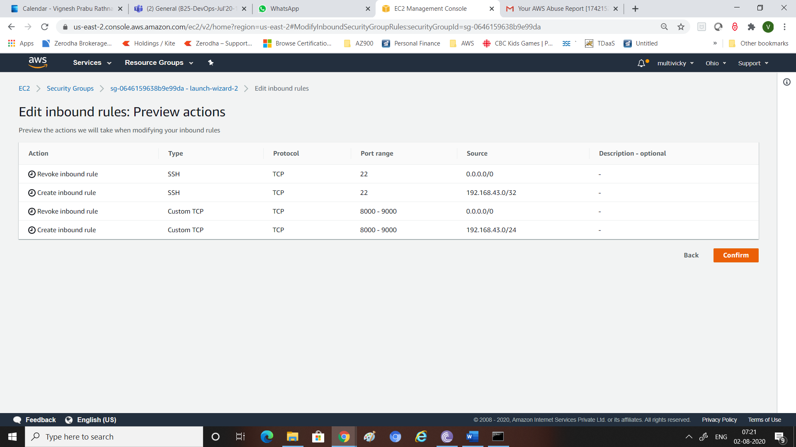

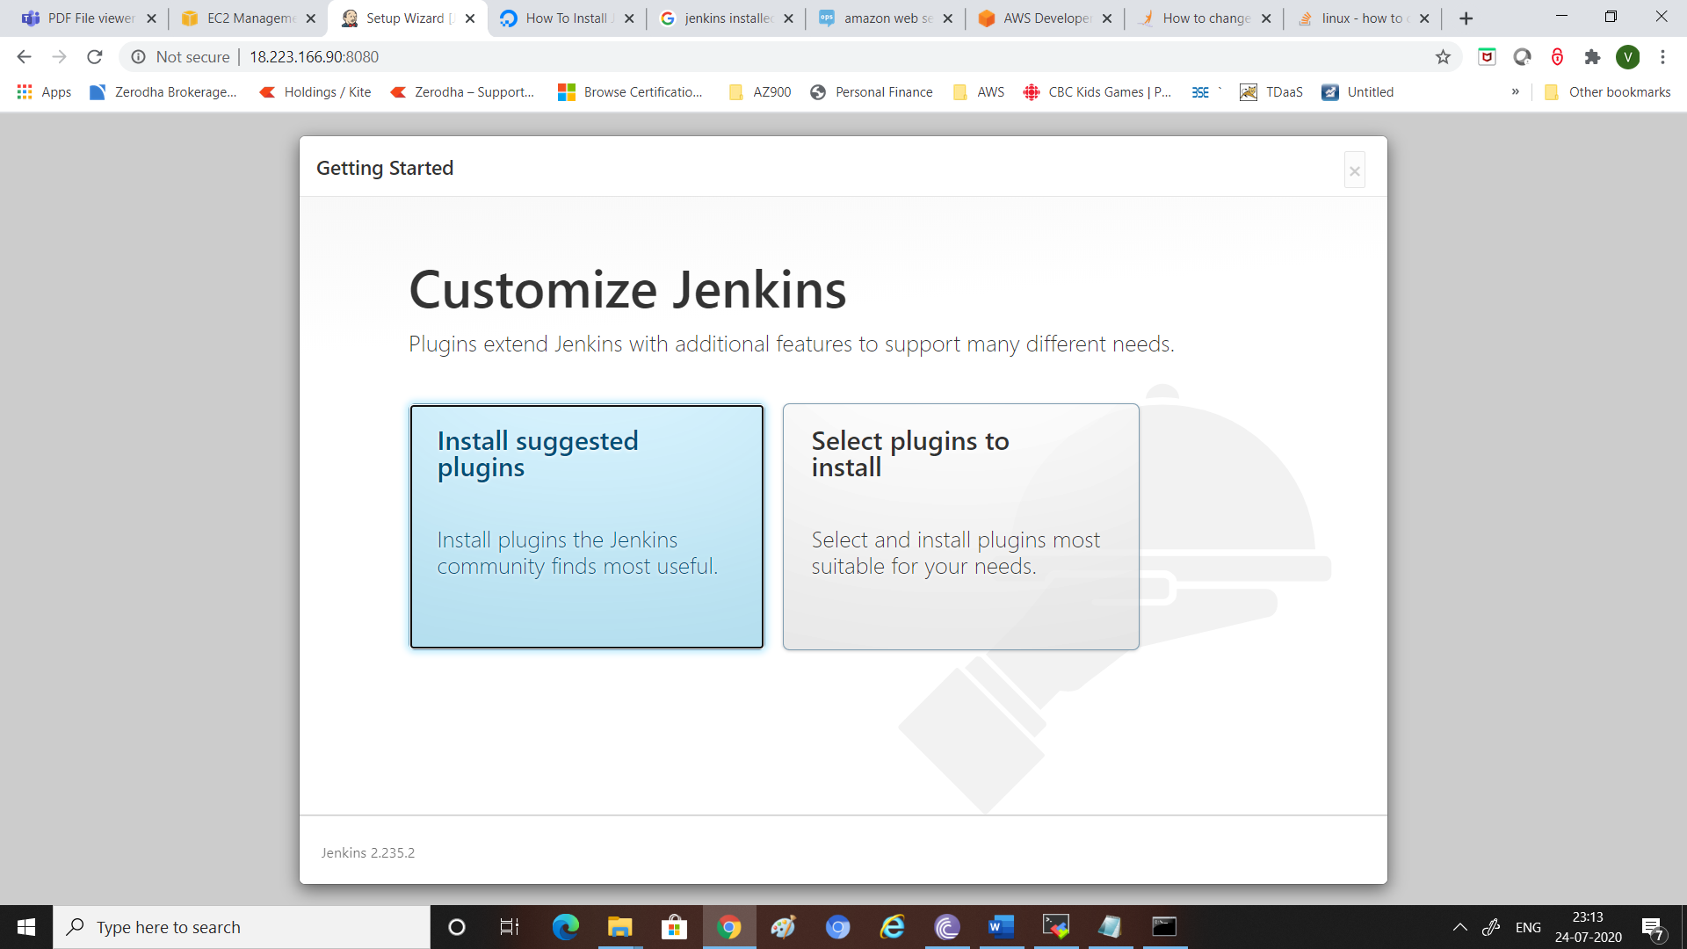

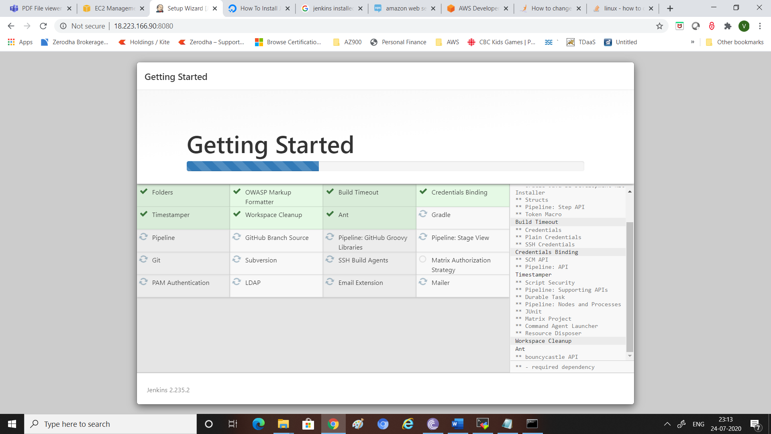

Continue as admin

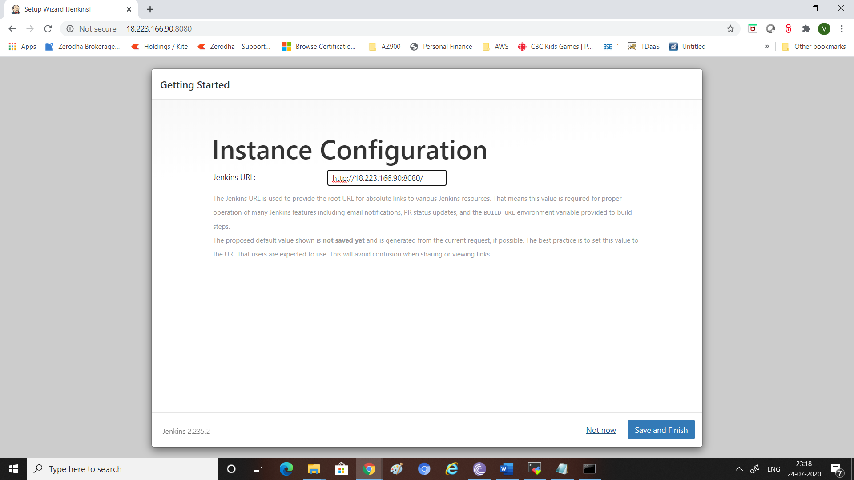

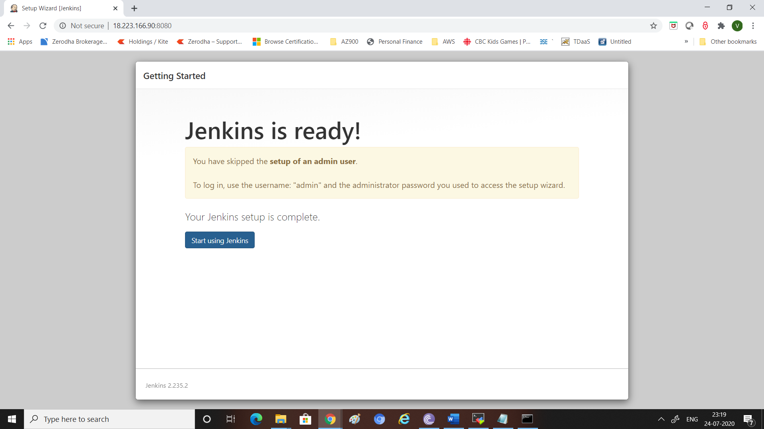

# GIT

Already installed

Sudo apt install git

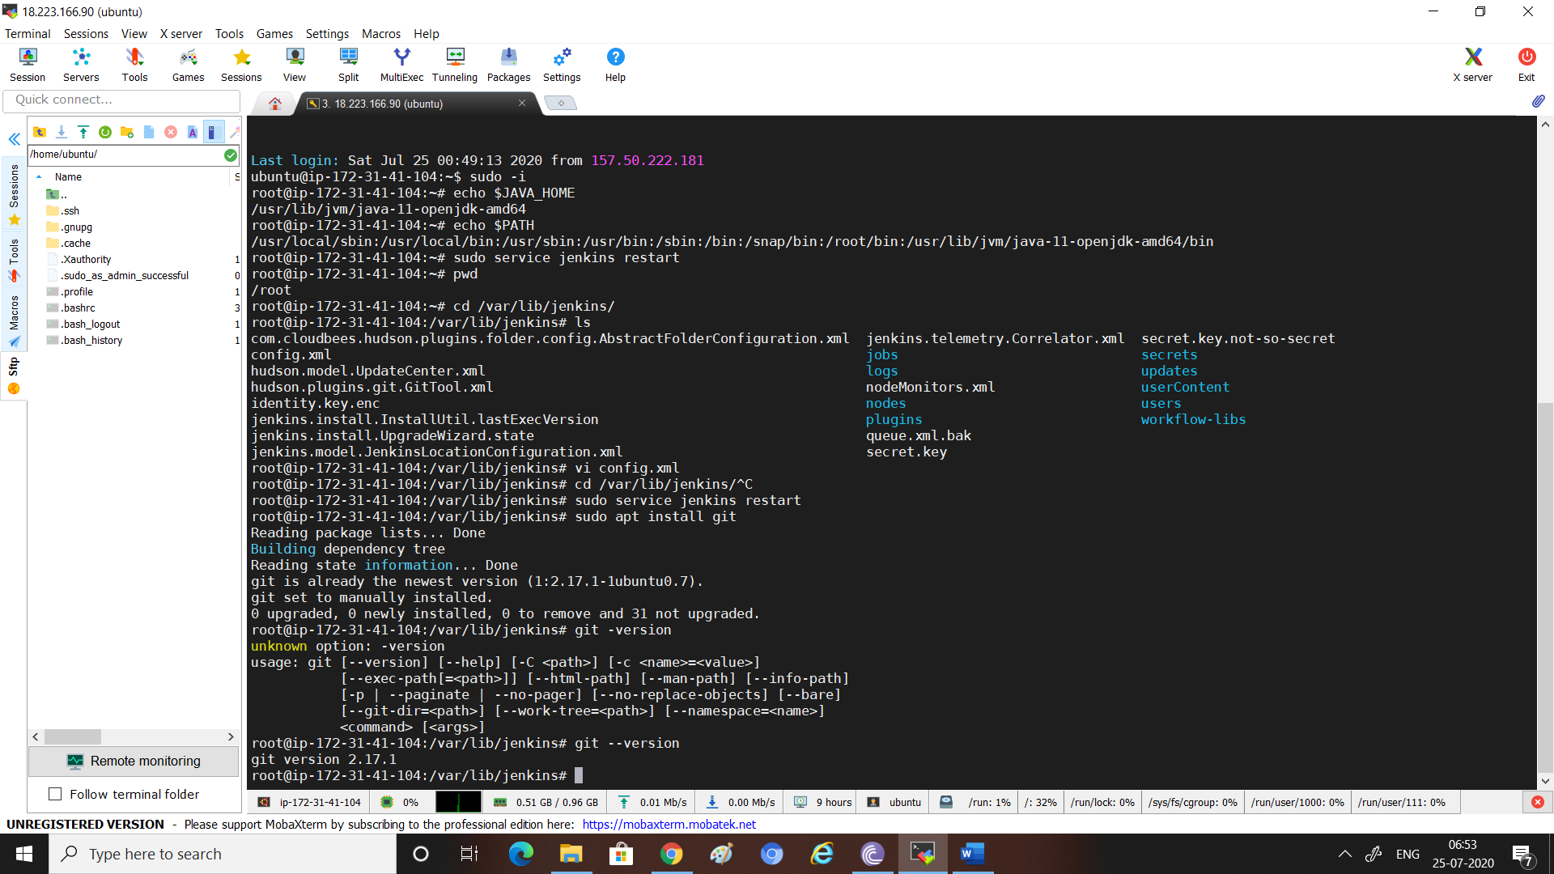

# Install maven

sudo apt install maven

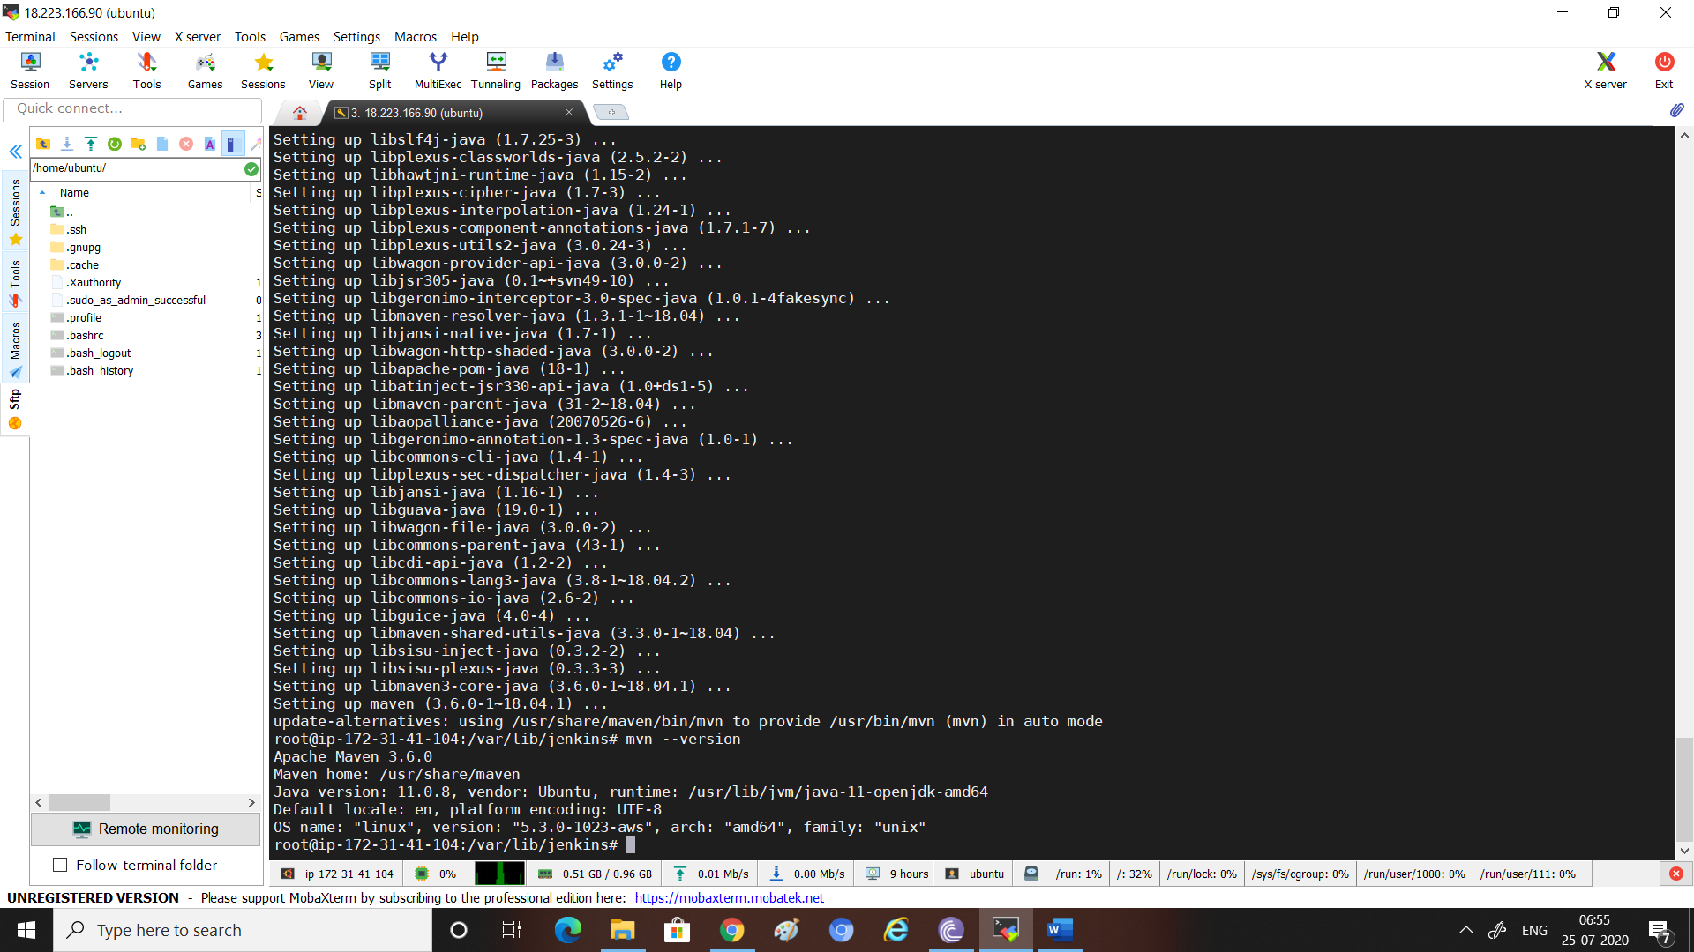

# Global tool config

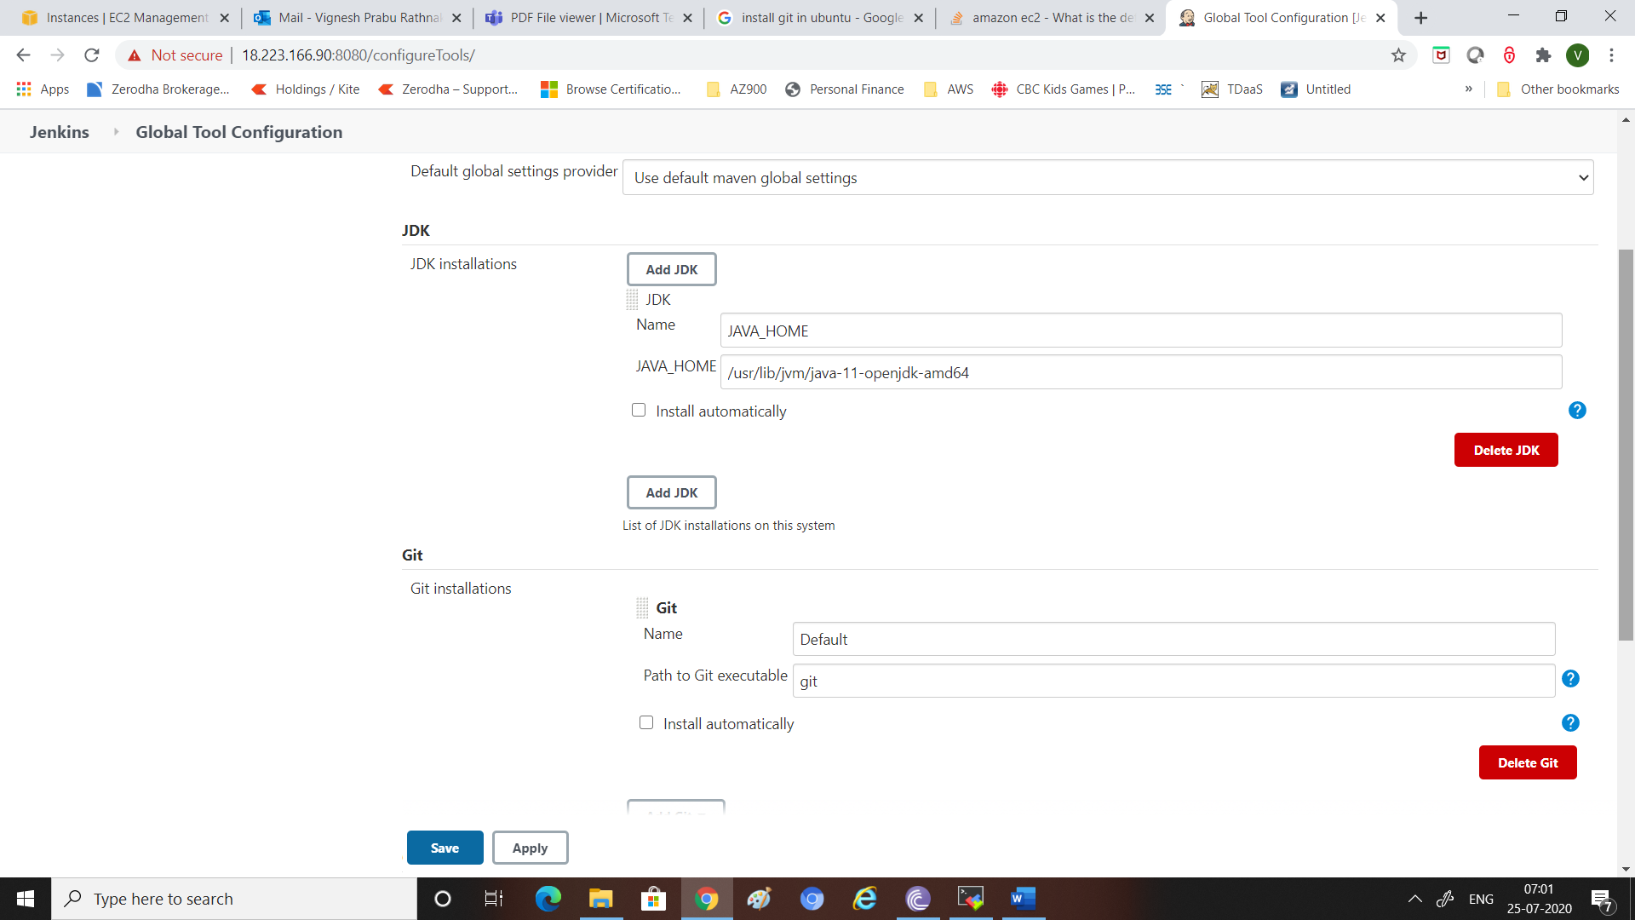

# JFrog

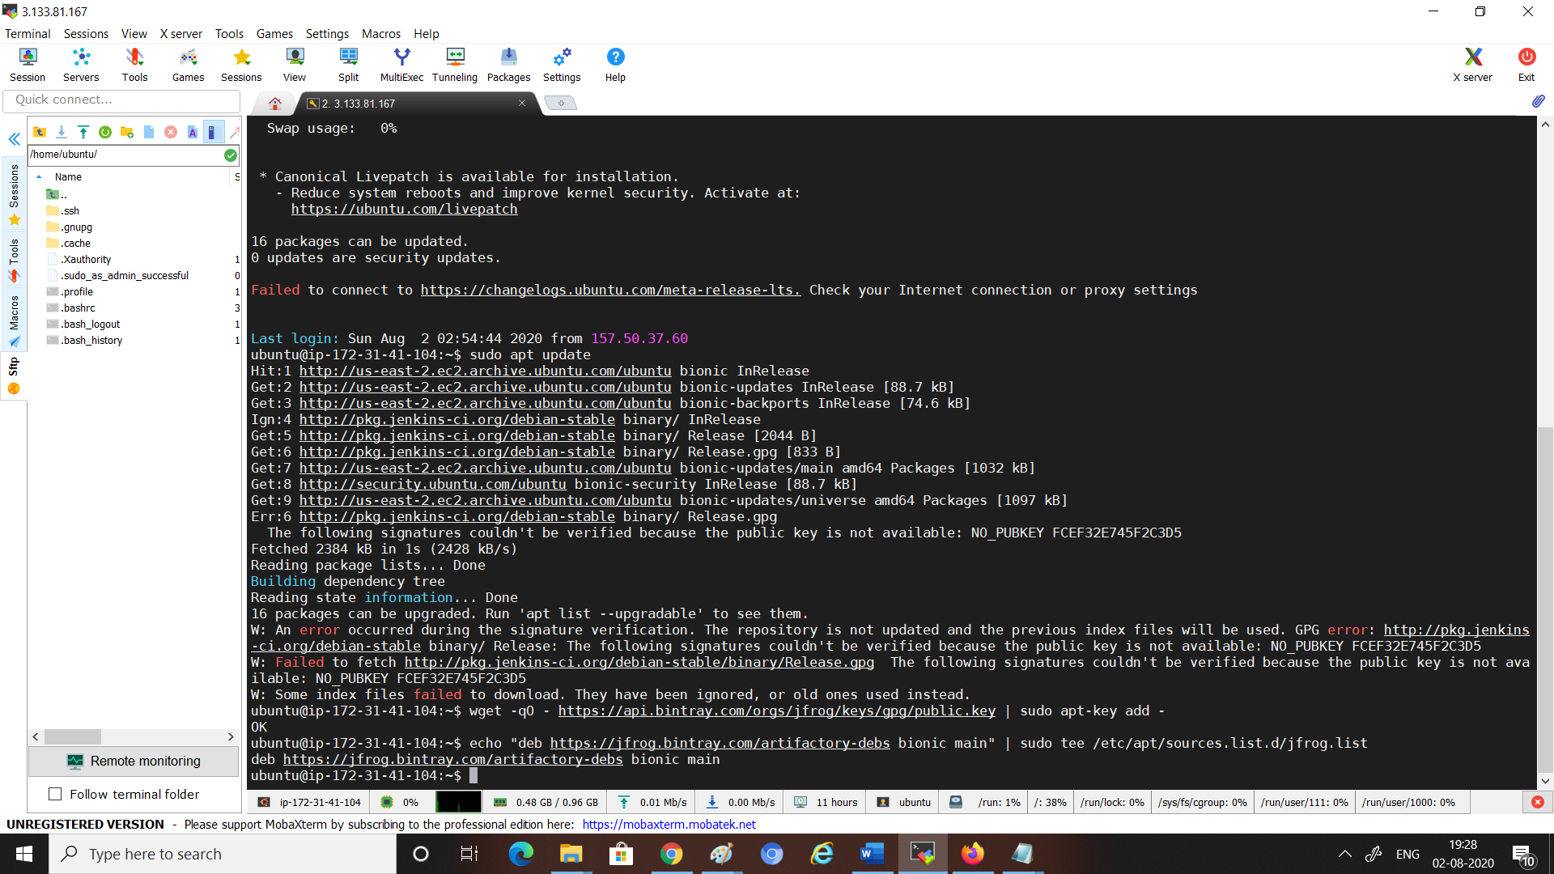

# 

# Password

Jenkins

Vignesh Vignesh123